SET 3: EMPLOYEE PERFORMANCE EVALUATION
Employee Performance Analysis using R and Tableau

Department | AIML
Course Code / Course Name | DSA0602/ Data Handling and Visualization
Experiment | Data Visualization using R
Name | S.Naveen Kumar
Register Number | 192425176
Date | 29 September 2026
Day | Tuesday

Aim
To visualize employee performance data using a line chart, bar chart, and scatter plot in R, and to build an interactive dashboard using Tableau.
Dataset: Employee Performance
Employee ID | Department | Years of Service | Performance Score
1 | Sales | 5 | 85
2 | HR | 3 | 92
3 | Marketing | 7 | 78
4 | Sales | 4 | 90
5 | HR | 2 | 76

PROGRAM 1: Line Chart of Performance Trend
Create a line chart to visualize the performance trend of employees over time (years of service). Include a legend and label the chart elements.
# Dataset
employee_id <- c(1, 2, 3, 4, 5)
department <- c("Sales", "HR", "Marketing", "Sales", "HR")
years <- c(5, 3, 7, 4, 2)
score <- c(85, 92, 78, 90, 76)
# Sort the data by years of service
ord <- order(years)
years_sorted <- years[ord]
score_sorted <- score[ord]
# Line Chart
plot(years_sorted, score_sorted,
type = "o",
pch = 19,
col = "blue",
xlab = "Years of Service",
ylab = "Performance Score",
main = "Performance Trend of Employees",
ylim = c(70, 100))
# Legend
legend("topright",
legend = "Performance Score",
col = "blue",
lty = 1,
pch = 19)
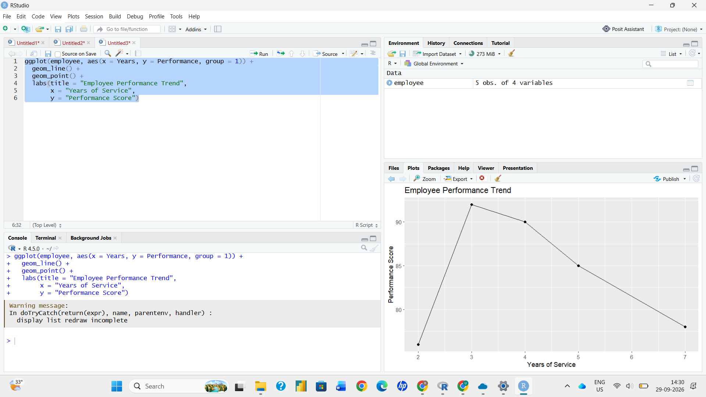

Output 1: Performance Trend of Employees
Observation: The performance score rises from 76 at 2 years of service to a peak of 92 at 3 years, then falls steadily to 90, 85, and 78 at 4, 5, and 7 years of service respectively.
PROGRAM 2: Bar Chart of Employees by Department
Generate a bar chart showing the distribution of employees across different departments. Label the chart elements.
# Dataset
department <- c("Sales", "HR", "Marketing", "Sales", "HR")
# Count employees in each department
dept_count <- table(department)
# Bar Chart
barplot(dept_count,
xlab = "Department",
ylab = "Number of Employees",
main = "Distribution of Employees by Department",
col = c("skyblue", "lightgreen", "orange"),
ylim = c(0, 3))
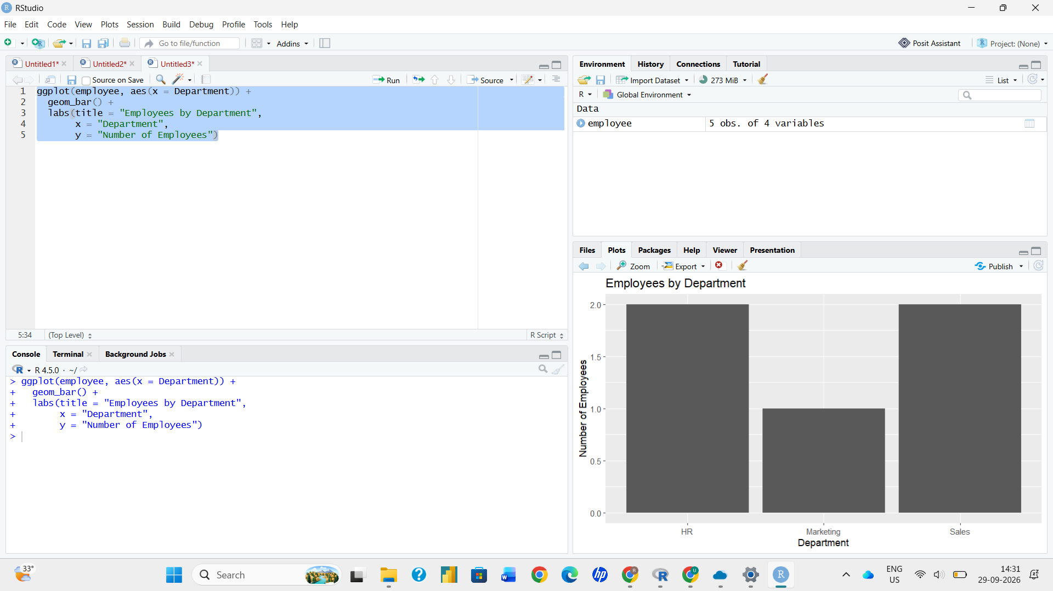

Output 2: Distribution of Employees by Department
Observation: HR and Sales each have 2 employees, while Marketing has 1 employee.
PROGRAM 3: Scatter Plot of Years of Service vs Performance Score
Build a scatter plot to analyze the correlation between years of service and performance scores, and explain any insights.
# Dataset
years <- c(5, 3, 7, 4, 2)
score <- c(85, 92, 78, 90, 76)
# Scatter Plot
plot(years, score,
main = "Years of Service vs Performance Score",
xlab = "Years of Service",
ylab = "Performance Score",
pch = 19,
col = "red")
# Trend line
abline(lm(score ~ years), col = "blue")
# Correlation coefficient
cor(years, score)
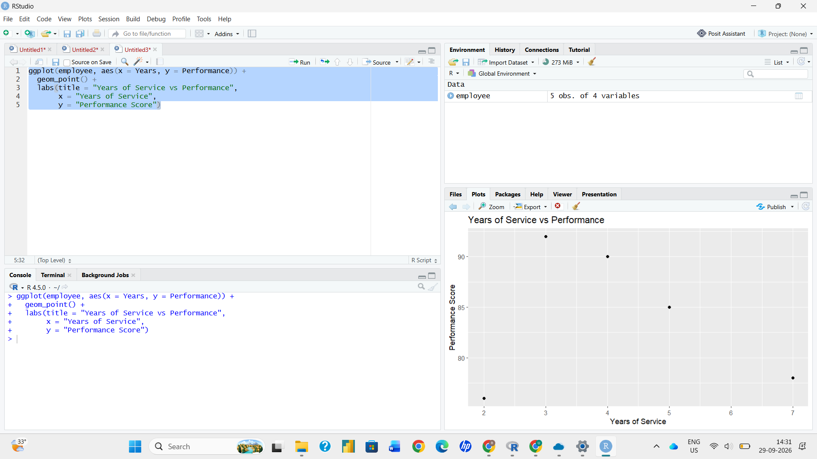

Output 3: Years of Service vs Performance Score
Insight: The correlation coefficient is about -0.17, which indicates a very weak negative relationship between years of service and performance score. The points are widely scattered and the trend line is almost flat, so years of service does not strongly predict performance in this data. With only five employees, this result should be treated as indicative rather than conclusive.
PROGRAM 4: Interactive Employee Performance Dashboard (Tableau)
Develop a Tableau dashboard with the line chart and bar chart for interactive exploration.
1. Save the dataset as a CSV file with the columns Employee ID, Department, Years of Service, and Performance Score. Open Tableau, choose Connect > Text file, and load the file.
2. Open Sheet 1 and rename it "Performance Trend". Drag Years of Service to Columns and Performance Score to Rows, set the mark type to Line, and drag Department to Color so that the legend appears.
3. Open a new sheet and rename it "Department Distribution". Drag Department to Columns and Employee ID to Rows (measure: Count Distinct), then drag Department to Color and show the mark labels.
4. Create a new Dashboard, drag both sheets onto it, and arrange them side by side.
5. Select the bar chart and click "Use as Filter", and add a Department filter, so that selecting a department updates the line chart.

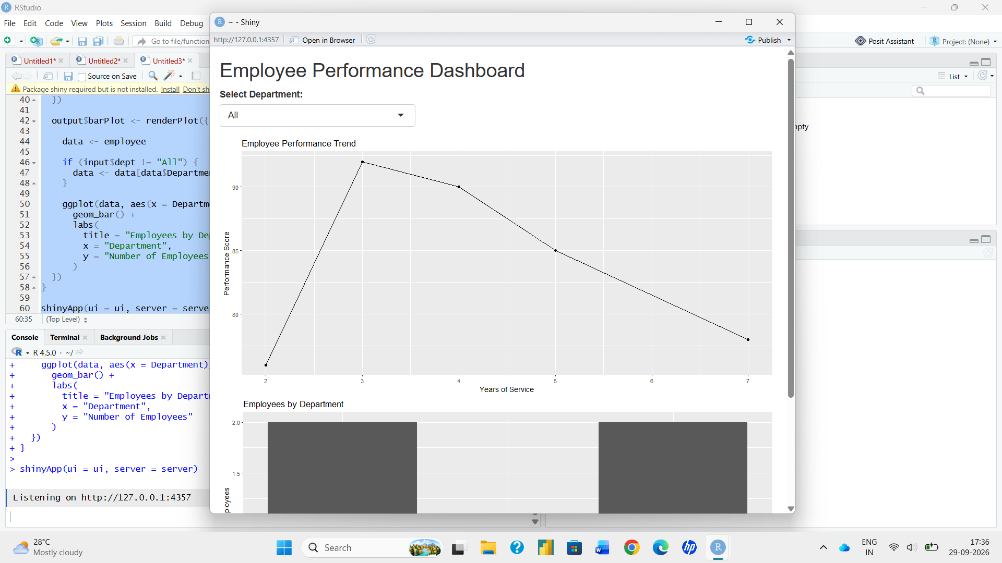

Output 4: Interactive Employee Performance Dashboard
Observation: The dashboard displays the performance trend and the department distribution together. Clicking a department in the bar chart filters the line chart to show only that department, which allows interactive exploration of the data.
Set 3 Procedure
1. Create vectors for employee ID, department, years of service, and performance score.
2. Sort the data by years of service, then use plot() with type = "o" and legend() to draw the line chart.
3. Use table() to count employees in each department and barplot() to draw the bar chart.
4. Use plot() and abline() to draw the scatter plot and cor() to measure the correlation.
5. Load the dataset into Tableau, build the line chart and bar chart worksheets, combine them in a dashboard, and enable "Use as Filter".
Set 3 Result
The employee performance data was successfully visualized using a line chart, bar chart, and scatter plot in R. An interactive Tableau dashboard combining the line chart and bar chart was also created.

